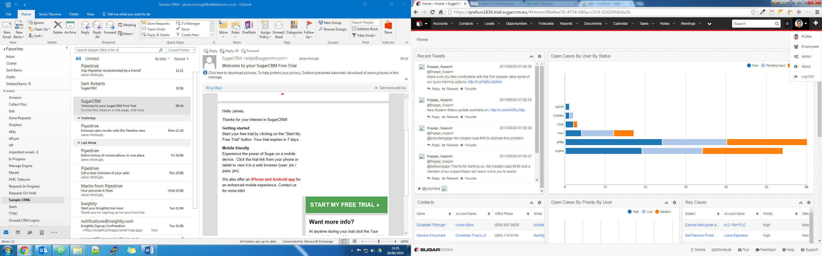

Existing CRM Designs

A guide to creating the new italk CRM

By James McHugh | Created on Thursday 6th October 6 2016

# Sugar CRM

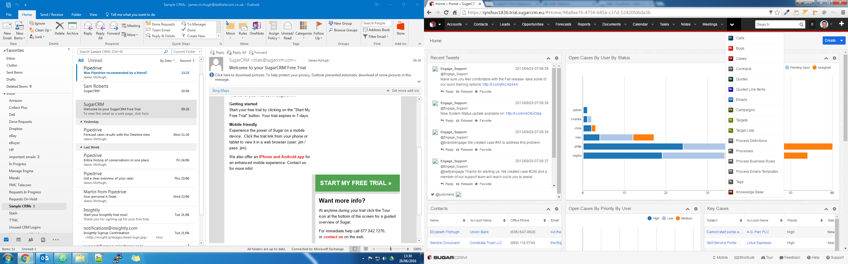

Fig.1.1

## General Concept

Sugar CRM is a CRM used for tracking sales from the point of conception through to the completion of the sale.

The theory behind the project is that the company that uses the CRM advertises their services through convential marketing methods or makes cold calls to obtain sales, as soon as sales is ready to be taken forward, the agent or member of staff will start a new sale using the ‘New Sale’ form.

## Starting a sale

The ‘New Sale’ form appears as lightbox (pop up) and has the following fields:

* Name of the customer
* Value
* Project
* Details
* Next Steps
* Date/Time Due
* Completed

The user fills in the fields in order to start a sale, this allows the CRM to store the sale into the database and allows all users and managers within the organisation to track and make changes to the sale thus completing the sale process. In each case the user can view the status of each case, messages/notes and view the details of the client. This will help the user to close the sales quickly and efficiently.

## Logging In For the first time

When a user logs in for the first time they are redirected to a registration page, where they can register to become a user.

The registration page is the initial landing page, however the user can switch at their own free will between the login page and back to the login page.The form has the following fields:

* Title
* Forename
* Surname
* Username
* Password
* Email address
* Organisation name
* Address of the Organisation
* The sector the organisation operates in
* Whether the user wishes to be included in marketing emails and newsletters

Once submitted the form makes enquiries into whether the data is of the correct format for submitting, then sanitises the data and finally queries the database to see if the user and/or the organisation already exists. If the user exists there is an link to a page that allows the user to fill in a form with their email address, this sends and email to them to allow them to reset their password. If the organisation already exists the page advises the user that the organisation already exists and cannot add them, furthermore it advises them to contact their administrator (the orginal user who set up the acccount) to set up their username and password.

## Logging In after the first time

Once a user has registered for an account or has been added by their administrator, the user can login through the login page, the user enters their email address as their username and their password to gain entry to the system.

Once submitted, just like the registration page, the page checks the fields to make sure that the fields are ready for submitting then sends them to the server to be sanitized and queried with the database. If the user does not exist or has incorrect credentials an error message is displayed t this effect and entry is not permitted. If the correct credentials are supplied the user connects to the CRM and proceeds to the control panel on the CRM.

## the control panel

CRM Logo/Home Button

Page Indicator/Breadcrumbs

Main Menu

User Profile Menu

Search Bar

Main Menu Overflow

Add user quick link



Contacts Menu (CRM Contacts with the organization)

Case statistics

Case Messages and notes

Key Open Cases

Open Cases

The control panel has a basic layout that is responsive to the screen size, each of the different components use lightweight features that use the latest in web technologies to bring forward the latest data from the database, which means that when the user has the screen open they have the latest data in real time.

The main control panel screen consists of the following components:

### Top Main menu



Fig. 1.2

The main menu (Fig.1.2) is a responsive menu and situated on the top of the page with the logo acting as a home button to take the user back to the control panel. The menu itself responds with the screen size, any menu items that overflow the current view are collapsed into a dropdown menu, where these items can be accessed. Menu items are organized by importance and by how often they will be used, since most languages read from left to right. The menu is the same no matter what page the user lands on and when the user scrolls up and down the menu remains at the top of the page, still retaining its responsive features.

In the right hand corner of the top menu (Fig.1.3) there is a button with a ‘plus’ sign on it, this is a quick link for admin users of the organization to add new users to the CRM.



Fig.1.3

Beside the add new user button is the profile drop down button for the current user. These give the user the ability administer and change their account, they cannot however, change user privileges, this is left to the administrator(s) of the CRM.

Notifications (Fig.1.4) are displayed in the top level menu as well, these are displayed in the way of having a number at the top, as soon as the user clicks on this number, the user is then greeted by a sliding menu with all the notifications for all the cases and day to day activities they have to complete, these can be marked as completed and users can put tasks back to be notified again in the future, add notes on the task and assign them to another agent.



Fig.1.4

The search button (Fig.1.4) is located beside the notifications counter, this allows the user to search for clients and bring them into the main view, all the details are for the customer/client are displayed in the main view.

### Page Indicator

The page indicator tells the user what page they are on. In modern web design pages can be single page design using JavaScript to hide and show features in the web page or even change the page completely, this allows the user to see if they are navigating away from the page, therefore keeping the data they have just entered on the page.

### Case Messages and Notes

The messages and notes section of the CRM allows users to leave notes on a particular case to alert the next user that deals with the client/customer of what is happening to the case or what is due to happen. This allows agents to continue the case if the original agent is busy or absent. This serves a good purpose when the case is passed onto the next stage to complete the sale.

As way of limiting what a user wants to see, they can customize the setting for this feature and only view what messages they want to see, this will allow users to clean up the messages and make viewing cases more efficient.

This view can be collapsed and expanded so the general view of the CRM can be customized.

Users can add notes to the case in order to build it and complete the case. This will help users to keep track of what events have lead up to making certain decisions on the case and track what events the business needs to plan for, this could help with improving the processes involved with a case.

### Case Statistics

Case statistics with this CRM are used to view different kind of statistics such as how often this case is looked, who looked at it and whether it has hit any target. However, the view can change to accommodate statistics about users on the CRM, they can view users based on how many sales they have on their file, they have closed and whether they are hitting targets.

### Contacts

The contacts section allows users to have all the contacts they need for the case and all cases they have, this is so that all resources are used in the completion of the sale.

### Open Cases

Open cases show the user all cases that are open by every sales agent, each sale is sorted in priority order and by user. The cases are color coded based on their priority, which allow users to differentiate between what is top of the priority list and what is at the bottom.

### Key open cases

Cases that are important and must be closed are displayed in this section, these are the cases that must be dealt with, these are very important clients or high value clients that will generate a lot of revenue to the business and/or generate a lot of contacts. This section is vital as a business’ survival depends on customers who return and spend a lot of money within the business.

## Advantages

* The overall design is clean and simple to use and users can have as little or as much as they would like to view
* Screen adjusts to the resolution of screen whilst keeping its overall general design
* All components adjust their size and/or position to fit on the screen, so users can find what they are looking for no matter what platrform they are on
* Menu items are labelled according to their function and each page serves the function it intended for
* Menu items are placed in order of how often they will be used and what purpose they are used for
* Users can administer their own accounts
* When a user is given administration priveleges they can create, delete and modify users (user priveleges, departments and what they can and cannot see)
* Users can search for clients with ease, bringing up all the details they need in one page
* Users can set their own notifications and alerts and set them when to notify them of when to take action on particular cases
* Users can add notes with ease, which are sorted in date order (recent first)
* Graphs and charts are used to represent data and all data is presented and labelled clearly
* Contacts displayed clearly and links are provided to access the details of that contact
* Users can see current open cases and view the high priority ones at the top
* Each component has an allocated space on the CRM interface and any overflow has scroll bars on.

## Disadvantages

* The CRM interface itself is only suitable for sales personnel only
* Payments cannot be taken through the CRM and payment details cannot be stored in the CRM database
* Messages in the message pane are in the form of tweets, therefore these are personal messages that do not need to be made public, it would be handy to have these messages on the CRM only
* Even though some of the components on the CRM speak for themselves and do not need any further instructions, some components will need them, it would be nice if a description of the item or component can be used when the user hovers over each component

# Pipedrive